Project Planning Phase
Project Planning Template (Product Backlog, Sprint Planning, Stories, Story points)
Date | 08 October 2026
Team ID | [TEAM ID]
Project Name | Auto Ticket Classification Using ServiceNow Flow Designer
Maximum Marks | 5 Marks

Product Backlog, Sprint Schedule, and Estimation (4 Marks)
Use the below template to create product backlog and sprint schedule
Sprint | Functional Requirement (Epic) | User Story Number | User Story / Task | Story Points | Priority | Team Members
Sprint-1 | Requirement Analysis | USN-1 | As an administrator, I document the business use case and requirements so that the scope of the automation is clear. | 2 | High | Harishkumar M
Sprint-1 | Configuration Management | USN-2 | As an administrator, I create the Project Update Set and make it current so that all changes are captured. | 1 | High | Kaliraja R
Sprint-1 | Documentation | USN-3 | As an administrator, I record the navigation steps in picture view so that the configuration can be repeated. | 2 | Medium | Sukisivam E
Sprint-1 | Ticket Creation | USN-4 | As a caller, I can create a ticket in the School IT Ticket table by entering my name and a short description. | 5 | High | Mohan Vaithiya P
Sprint-2 | Data Structure | USN-5 | As an administrator, I create all required fields with the correct data types and choices. | 3 | High | Logeshkannan S
Sprint-2 | Dependent Choice | USN-6 | As an administrator, I make Subcategory choices depend on the selected Category. | 2 | Medium | Logeshkannan S
Sprint-2 | Automatic Classification | USN-7 | As IT staff, I want a flow to run when a ticket is created so that the ticket text can be analysed automatically. | 5 | High | All team members
Sprint-3 | Automatic Classification | USN-8 | As IT staff, I want keywords in the ticket to set the Category and Subcategory. | 5 | High | All team members
Sprint-3 | Email Notification | USN-9 | As a caller, I receive an email when my ticket is created. | 3 | Medium | All team members
Sprint-3 | Ticket Creation | USN-10 | As a caller, I do not have to select the Category or Subcategory myself. | 2 | High | All team members
Sprint-4 | Testing, Validation & Security | USN-11 | As an administrator, I validate the automation and restrict access so that only authorized users can modify ticket data. | 5 | High | All team members
Sprint-4 | Deployment & Conclusion | USN-12 | As an administrator, I mark the Project Update Set as Complete and conclude the project. | 5 | Medium | Sukisivam E

Project Tracker, Velocity & Burndown Chart: (4 Marks)
Sprint | Total Story Points | Duration | Sprint Start Date | Sprint End Date (Planned) | Story Points Completed (as on Planned End Date) | Sprint Release Date (Actual)
Sprint-1 | 10 | 6 Days | 07 Sep 2026 | 12 Sep 2026 | 10 | 12 Sep 2026
Sprint-2 | 10 | 6 Days | 14 Sep 2026 | 19 Sep 2026 | 10 | 19 Sep 2026
Sprint-3 | 10 | 6 Days | 21 Sep 2026 | 26 Sep 2026 | 10 | 26 Sep 2026
Sprint-4 | 10 | 6 Days | 28 Sep 2026 | 03 Oct 2026 | 10 | 03 Oct 2026

Velocity:
The sprint duration is 6 days and each sprint delivers 10 story points. Total story points = 10 + 10 + 10 + 10 = 40 across 4 sprints.
Average Velocity (AV) = Total story points completed / Number of sprints = 40 / 4 = 10 story points per sprint.
Velocity per day = Sprint velocity / Sprint duration = 10 / 6 ≈ 1.67 story points per day.
Burndown Chart:
A burndown chart is a graphical representation of work left to do versus time. The chart below shows the story points remaining for the project over the 24 working days of the four sprints, compared with the ideal burndown line.
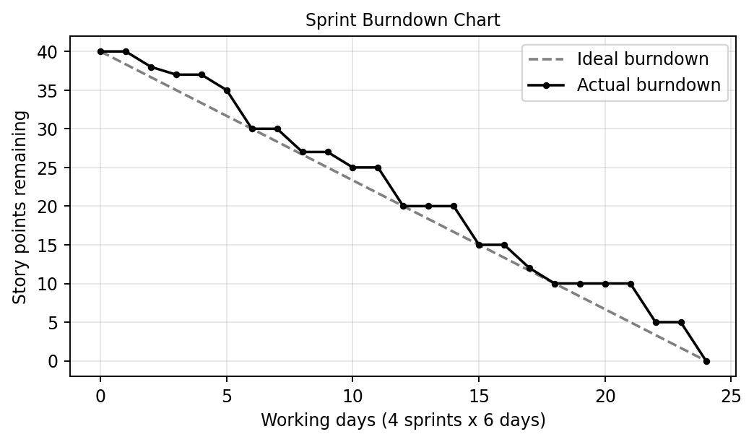
Reference:
https://www.atlassian.com/agile/project-management
https://www.atlassian.com/agile/tutorials/epics
https://www.atlassian.com/agile/tutorials/sprints
https://www.atlassian.com/agile/project-management/estimation
https://www.atlassian.com/agile/tutorials/burndown-charts

